How to filter in an Analytics report for fields which contain a semicolon | 

Yoel Kortick
Senior Librarian

Question:
I would like to filter by the field “Internal Note 1” in the “Physical Item Details” folder of the “Fulfillment” subject area for all notes which have a semicolon.
The problem is that when I filter “contains any” and use a semicolon I get a message “The operator 'contains any' requires at least 1 value(s).”

I put in a semicolon:

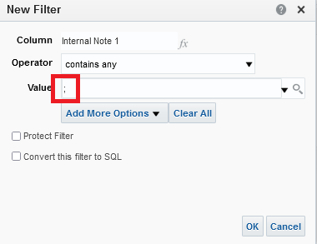

Then after I click OK I get this:

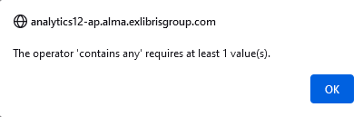

Answer:

We will do this using an SQL query

ONE
Do the filter with “Contains Any” and instead of using a semicolon use any other character such as the letter “a” and check the box “Convert this filter to SQL”. Click “OK”

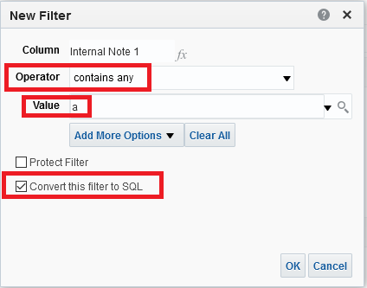

TWO
Edit the SQL filter

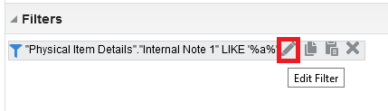

THREE
Replace the “a” with a semicolon.
Instead of this:

"Physical Item Details"."Internal Note 1" LIKE '%a%'

Have this:

"Physical Item Details"."Internal Note 1" LIKE '%;%'

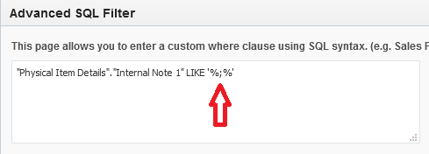

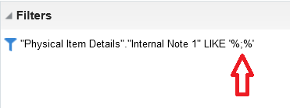

FOUR
Run the report and see that all fields retrieved have a semicolon.

